James Liu

CS 4495, Computer Vision

Fall 2014

Problem Set 5

**Problem Set 5, Question 1, Part 1, Image 1**

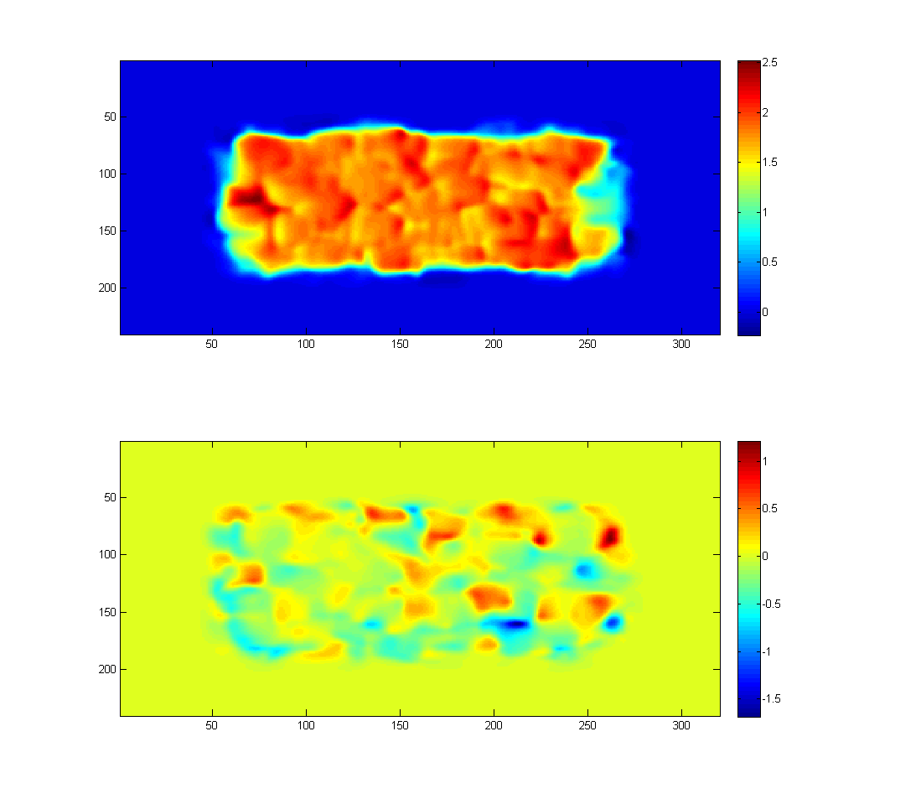

The optical flow image from Shift0 to ShiftR2, blurred with a Gaussian filter of size 21 with sigma 8. U values are in the top plot, the V values are in the bottom plot, the scales for which are on the right.

**Problem Set 5, Question 1, Part 1, Image 2**

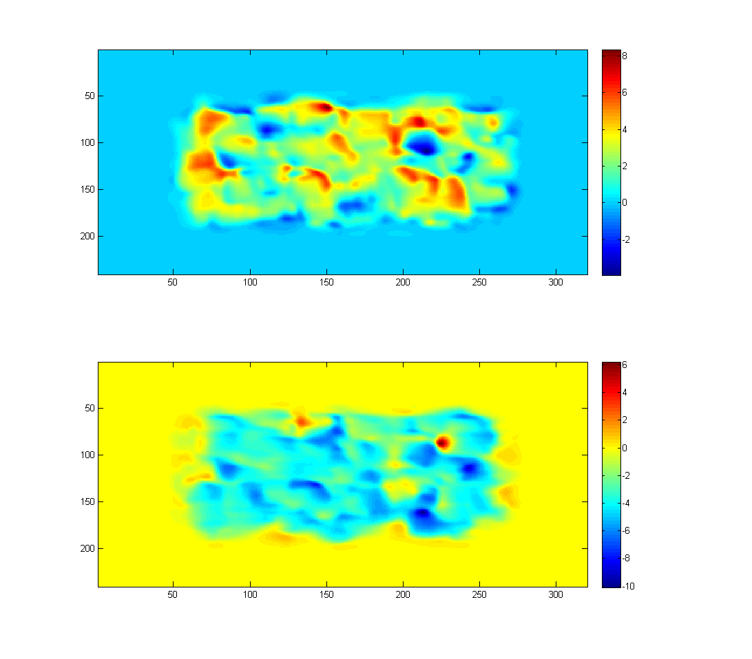

The optical flow image from Shift0 to ShiftR5U5, blurred with a Gaussian filter of size 21 with sigma 8. U values are in the top plot, the V values are in the bottom plot, the scales for which are on the right. Note that negative V values mean that flow is moving upwards.

**Problem Set 5, Question 1, Part 2, Image 1**

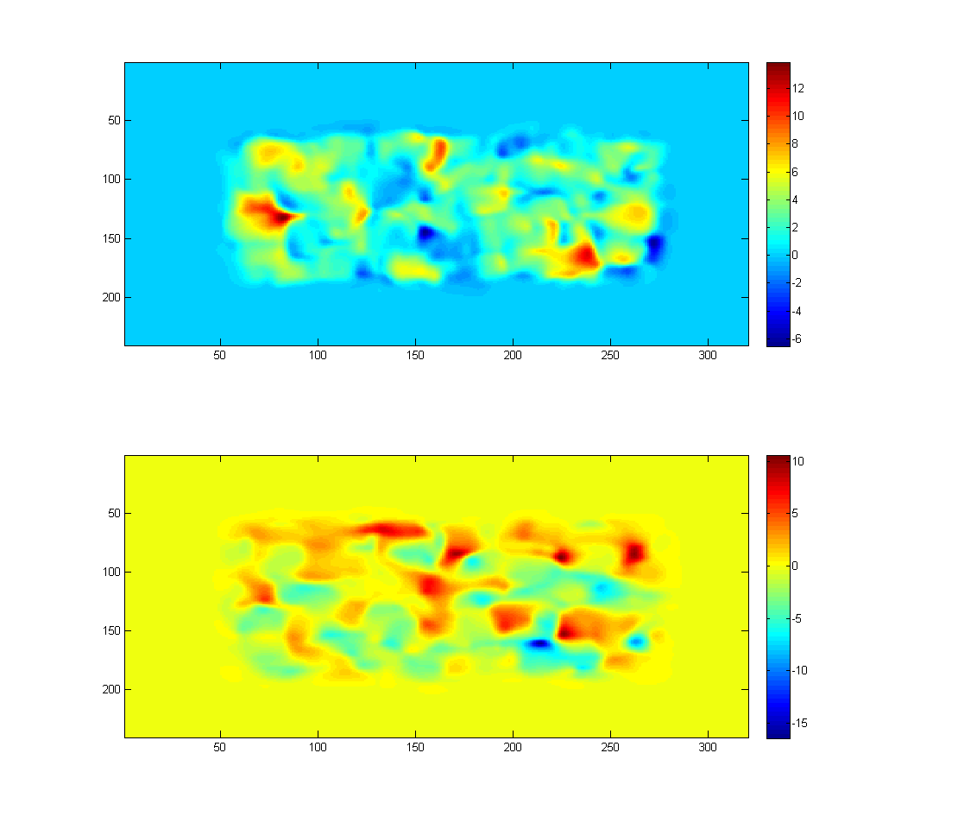

The optical flow image from Shift0 to ShiftR10, blurred with a Gaussian filter of size 21 with sigma 8. U values are in the top plot, the V values are in the bottom plot, the scales for which are on the right. Note that negative V values mean that flow is moving upwards. Also note that the entire center rectangle is no longer uniformly moving in one direction. This is due to how optic flow is computed. It makes the assumption that spatial and temporal movement is small, and does not deal well with movements that are large in scale over a short timespan.

**Problem Set 5, Question 1, Part 2, Image 2**

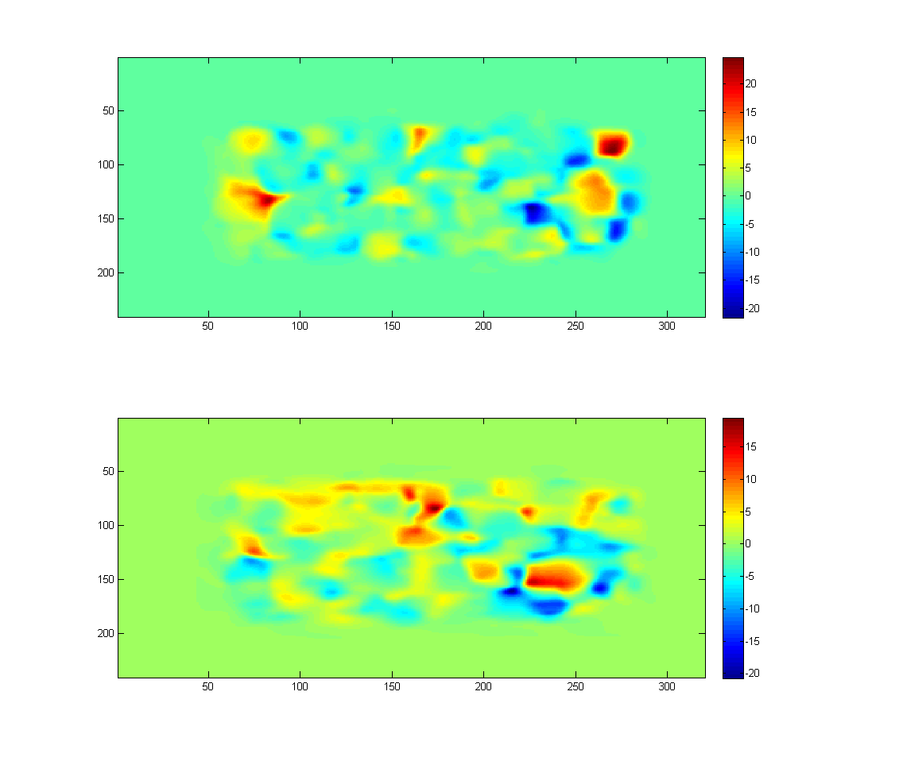

The optical flow image from Shift0 to ShiftR20, blurred with a Gaussian filter of size 21 with sigma 8. U values are in the top plot, the V values are in the bottom plot, the scales for which are on the right. As mentioned before, even larger movements will further increase the error.

**Problem Set 5, Question 1, Part 2, Image 3**

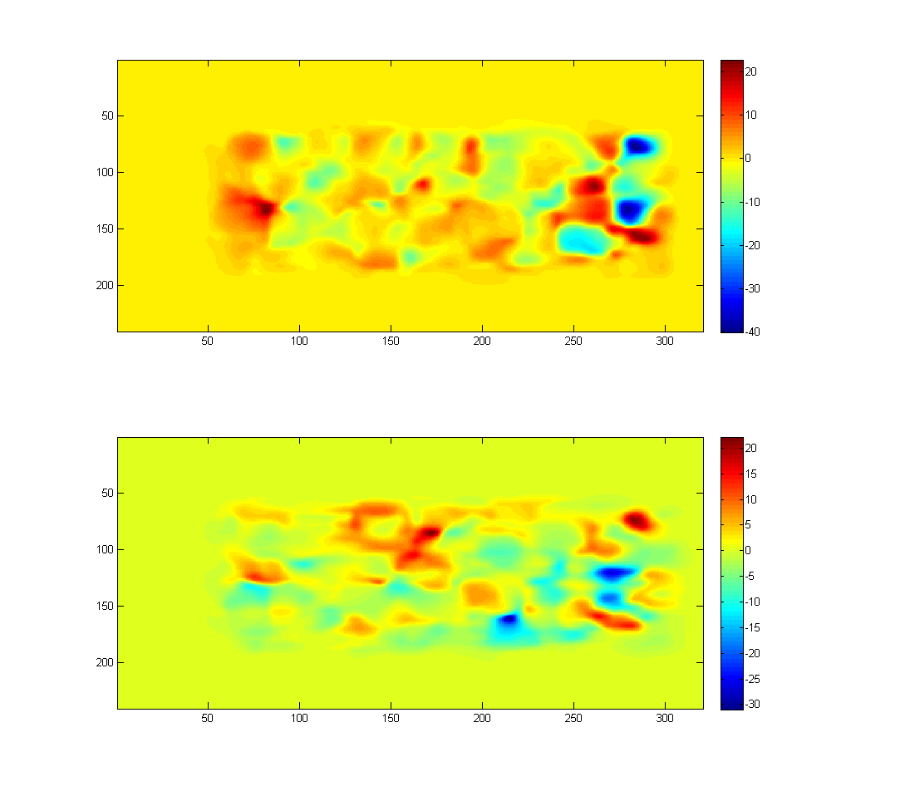

The optical flow image from Shift0 to ShiftR40, blurred with a Gaussian filter of size 21 with sigma 8. U values are in the top plot, the V values are in the bottom plot, the scales for which are on the right. As mentioned before, even larger movements will further increase the error.

**Problem Set 5, Question 2, Part 1, Images**

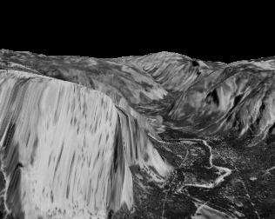 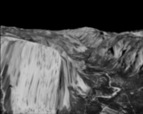  

The bottom four levels of the Gaussian pyramid for yos_img_01.

**Problem Set 5, Question 2, Part 2, Images**



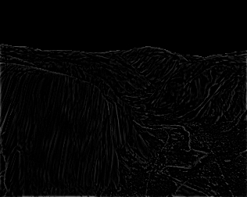 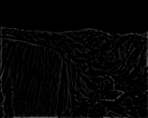 

The bottom four levels of the Laplacian pyramid for yos_img_01.

**Problem Set 5, Question 3, Part 2.3, Images for yos_img_01 → yos_img_02 (DataSeq1)**

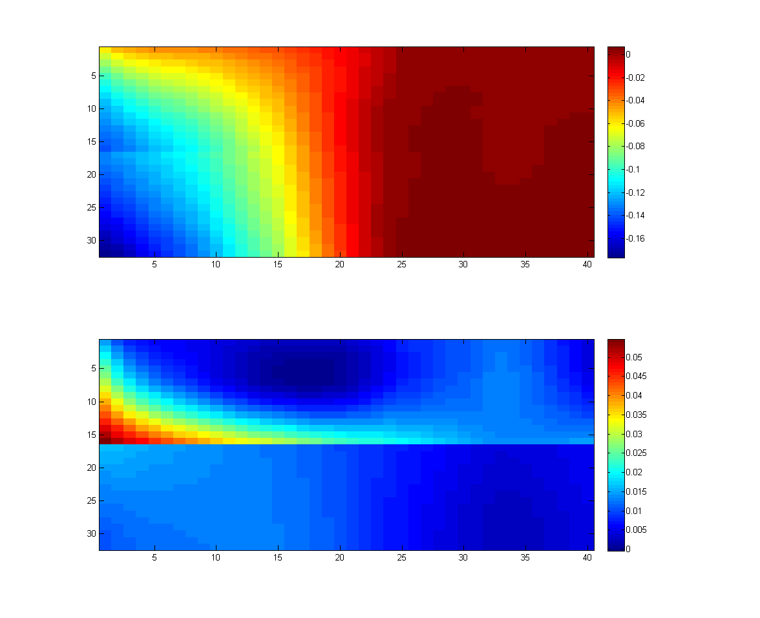

Displacement between yos_img_01 and yos_img_02, as calculated by a single level LK computation, at level k=4, it used a Gaussian filter with window size 30, and sigma 13.

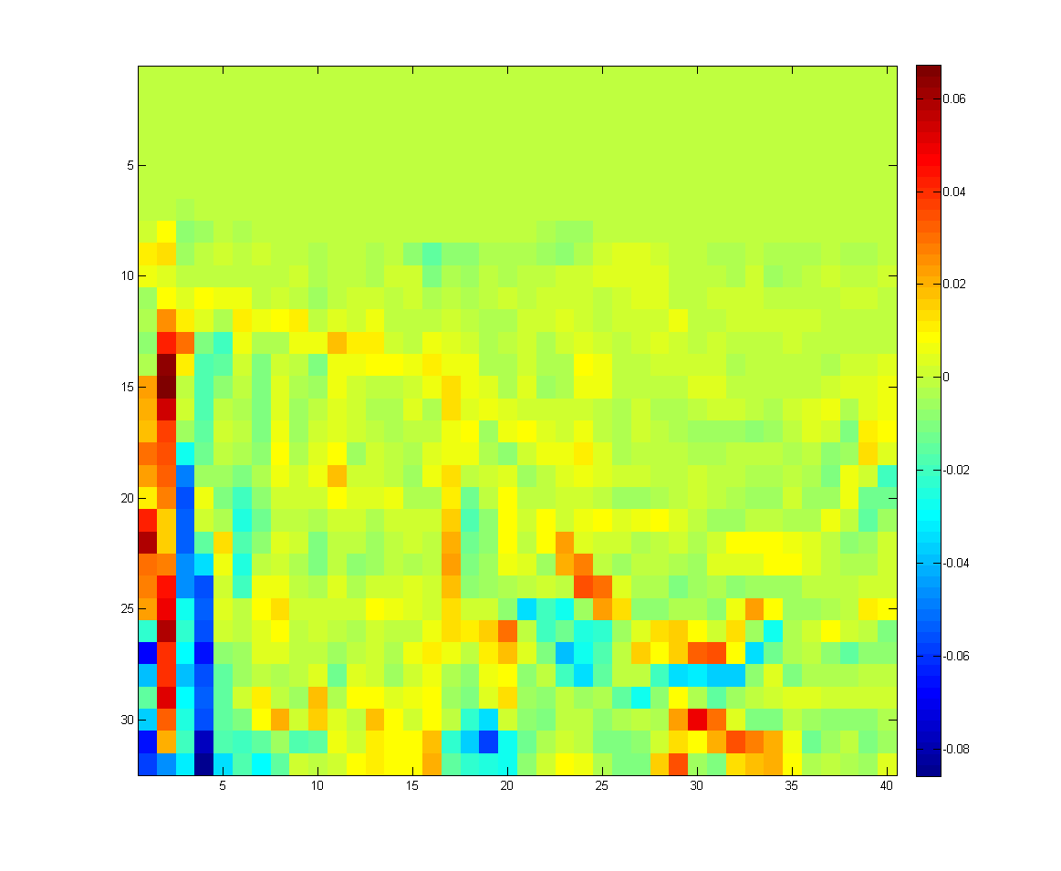

Difference image between yos_img_01 and warped yos_img_02, as calculated by a single level LK computation, at level k=4, it used a Gaussian filter with window size 30, and sigma 13.

**Problem Set 5, Question 3, Part 2.3, Images for yos_img_02 → yos_img_03 (DataSeq1)**

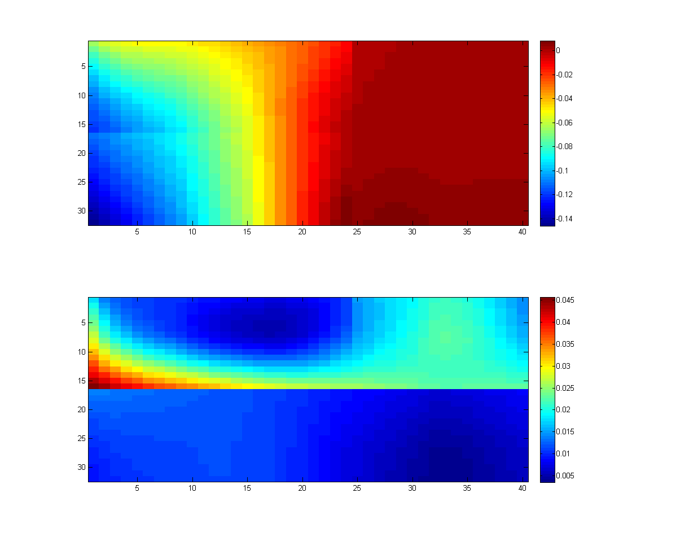

Displacement between yos_img_02 and yos_img_03, as calculated by a single level LK computation, at level k=4, it used a Gaussian filter with window size 30, and sigma 13.

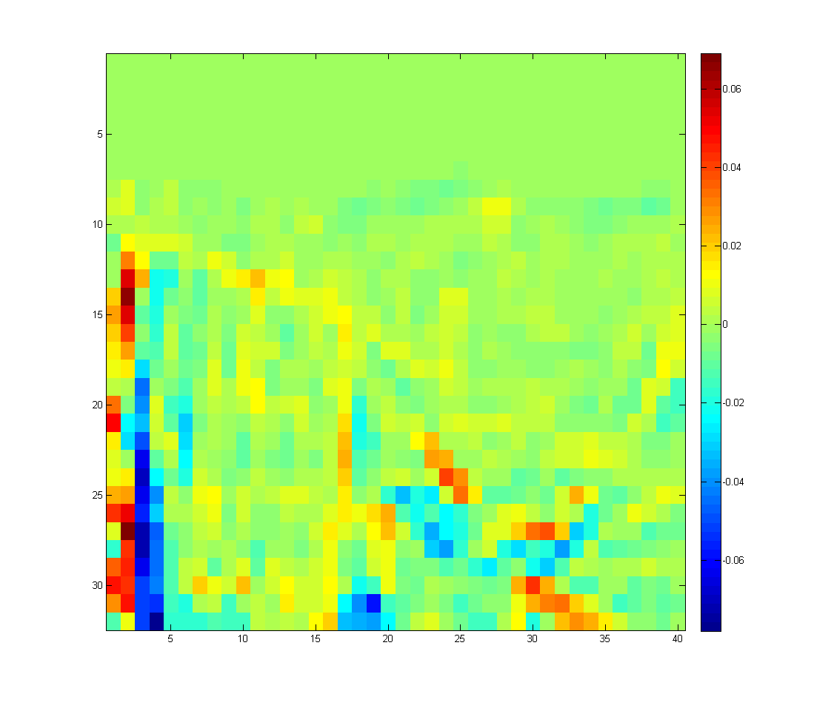

Difference image between yos_img_02 and warped yos_img_03, as calculated by a single level LK computation, at level k=4, it used a Gaussian filter with window size 30, and sigma 13.

**Problem Set 5, Question 3, Part 2.3, Images for 0 → 1 (DataSeq2)**

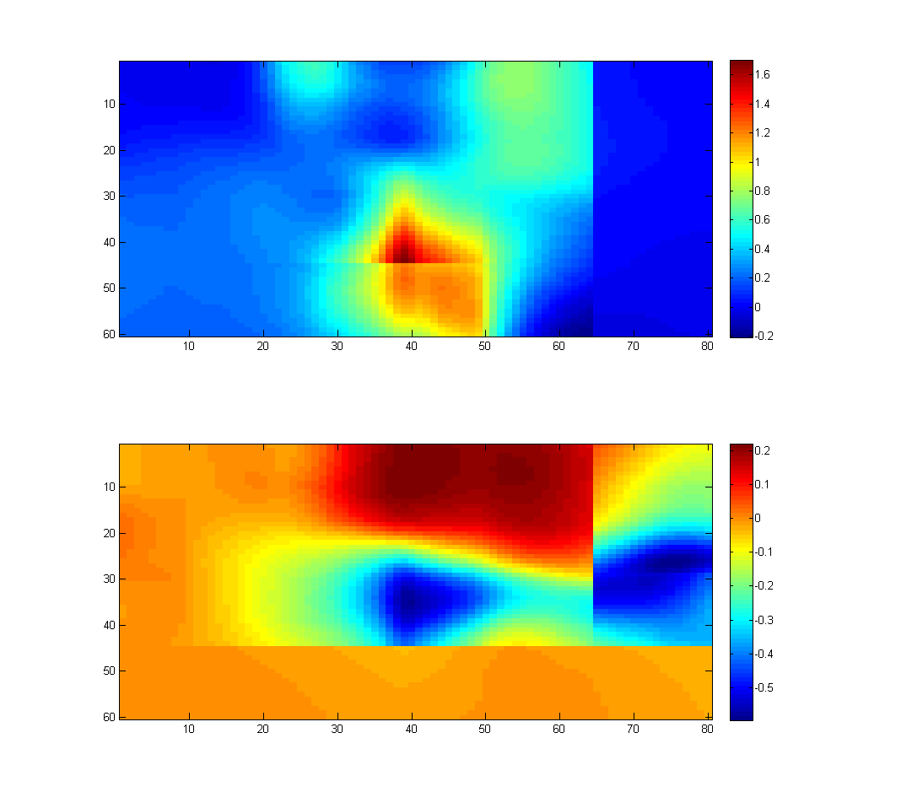

Displacement between 0 and 1, as calculated by a single level LK computation, at level k=4, it used a Gaussian filter with window size 30, and sigma 13.

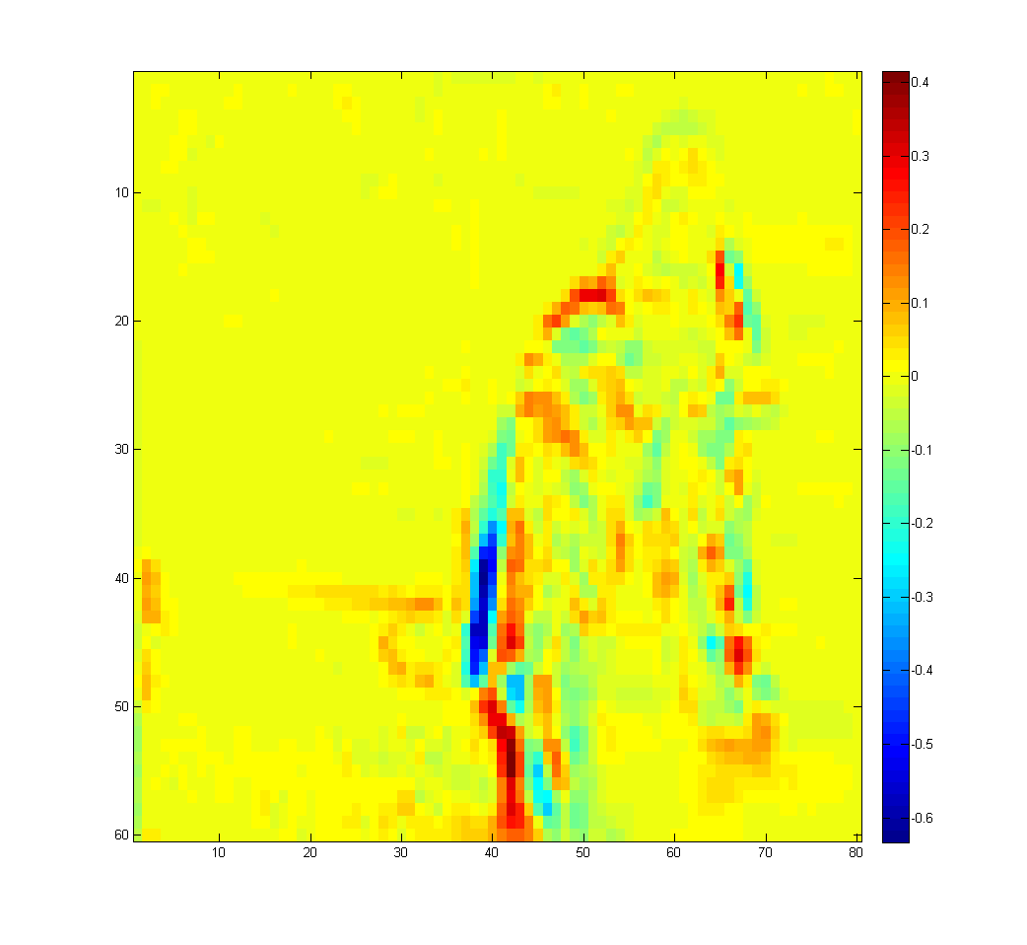

Difference image between 0 and warped 1, as calculated by a single level LK computation, at level k=4, it used a Gaussian filter with window size 30, and sigma 13.

**Problem Set 5, Question 3, Part 2.3, Images for 1 → 2 (DataSeq2)**

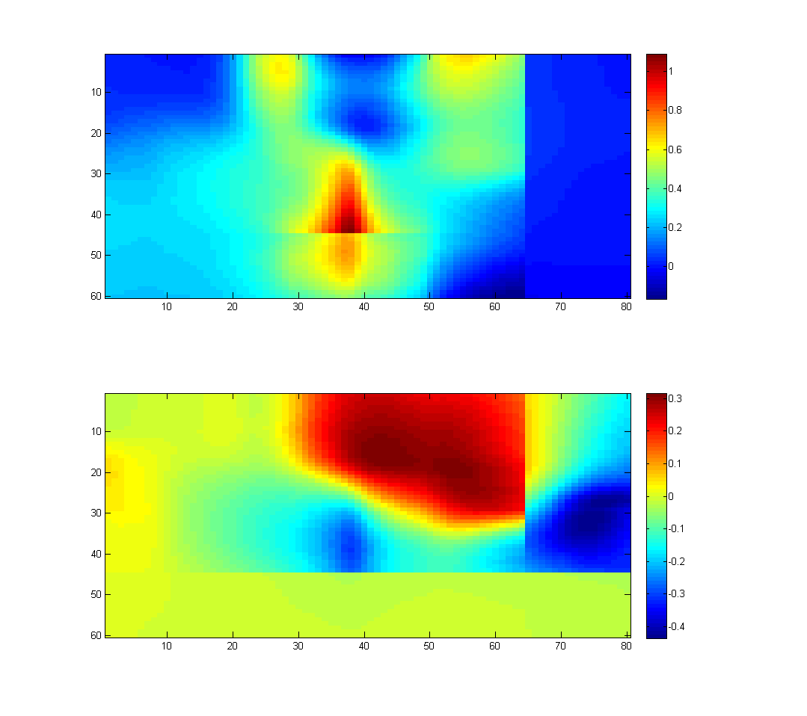

Displacement between 1 and 2, as calculated by a single level LK computation, at level k=4, it used a Gaussian filter with window size 30, and sigma 13.

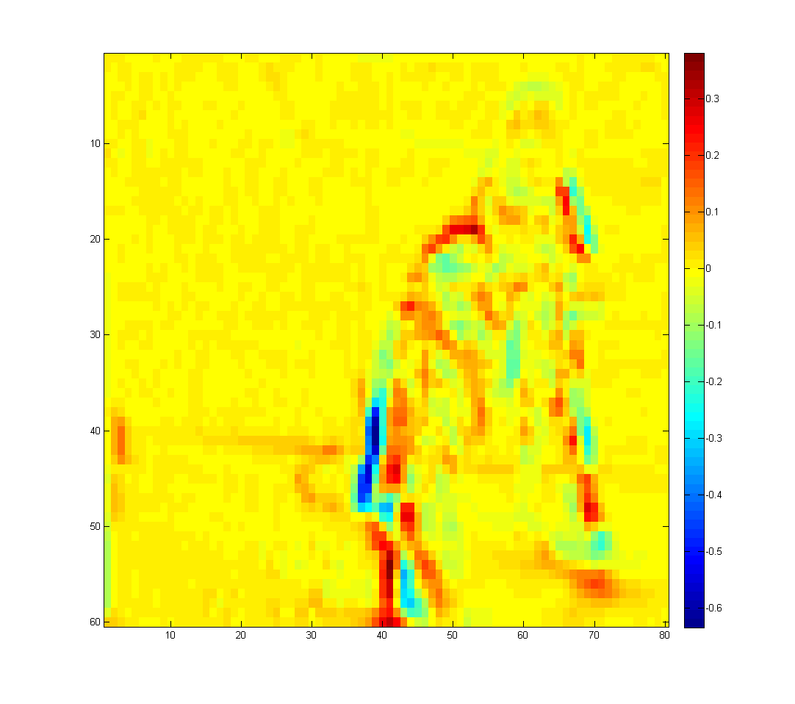

Difference image between 1 and warped 2, as calculated by a single level LK computation, at level k=4, it used a Gaussian filter with window size 30, and sigma 13.

**Problem Set 5, Question 4, Part 1, Images for Shift0 → Shift10 (TestSeq)**

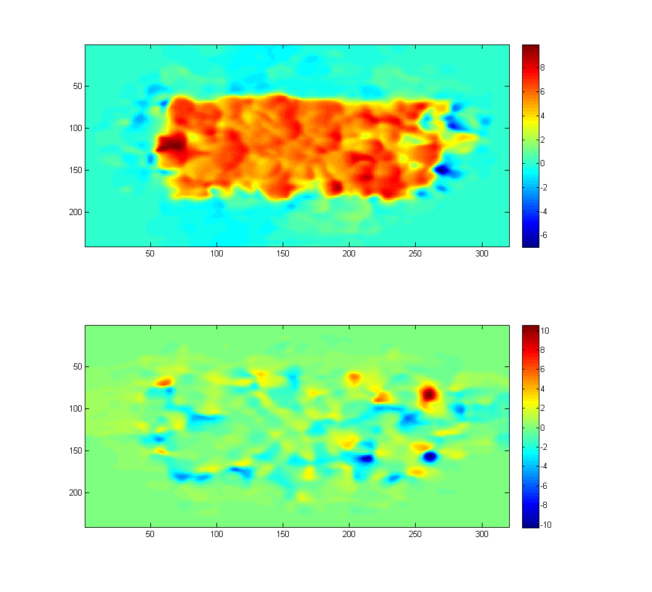

Displacement between Shift0 and Shift10, as calculated by a hierarchical LK method, where k=7, each LK operation used a Gaussian filter with window size 30, and sigma 15.

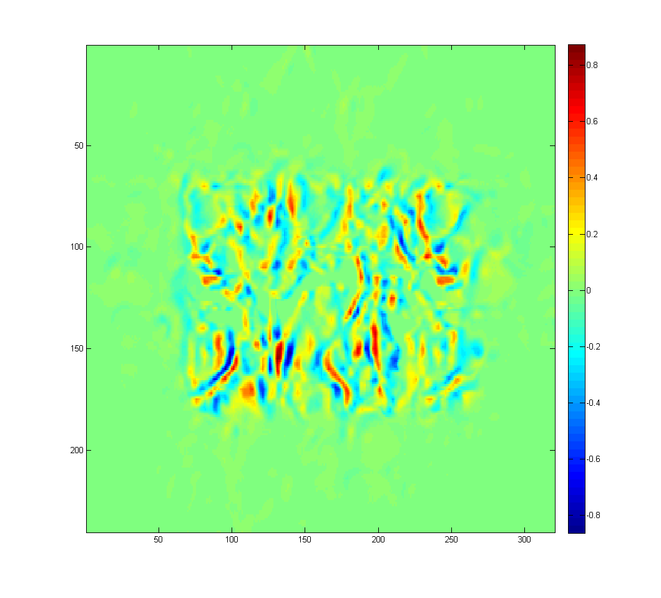

Difference image between Shift0 and warped Shift10, as calculated by a hierarchical LK method, where k=7, each LK operation used a Gaussian filter with window size 30, and sigma 15.

**Problem Set 5, Question 4, Part 1, Images for Shift0 → Shift20 (TestSeq)**

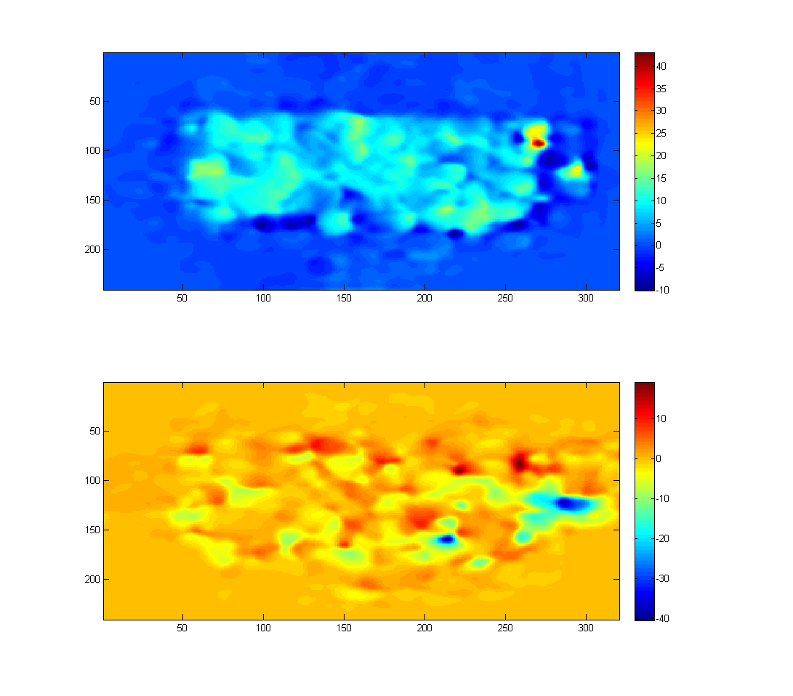

Displacement between Shift0 and Shift20, as calculated by a hierarchical LK method, where k=7, each LK operation used a Gaussian filter with window size 30, and sigma 15.

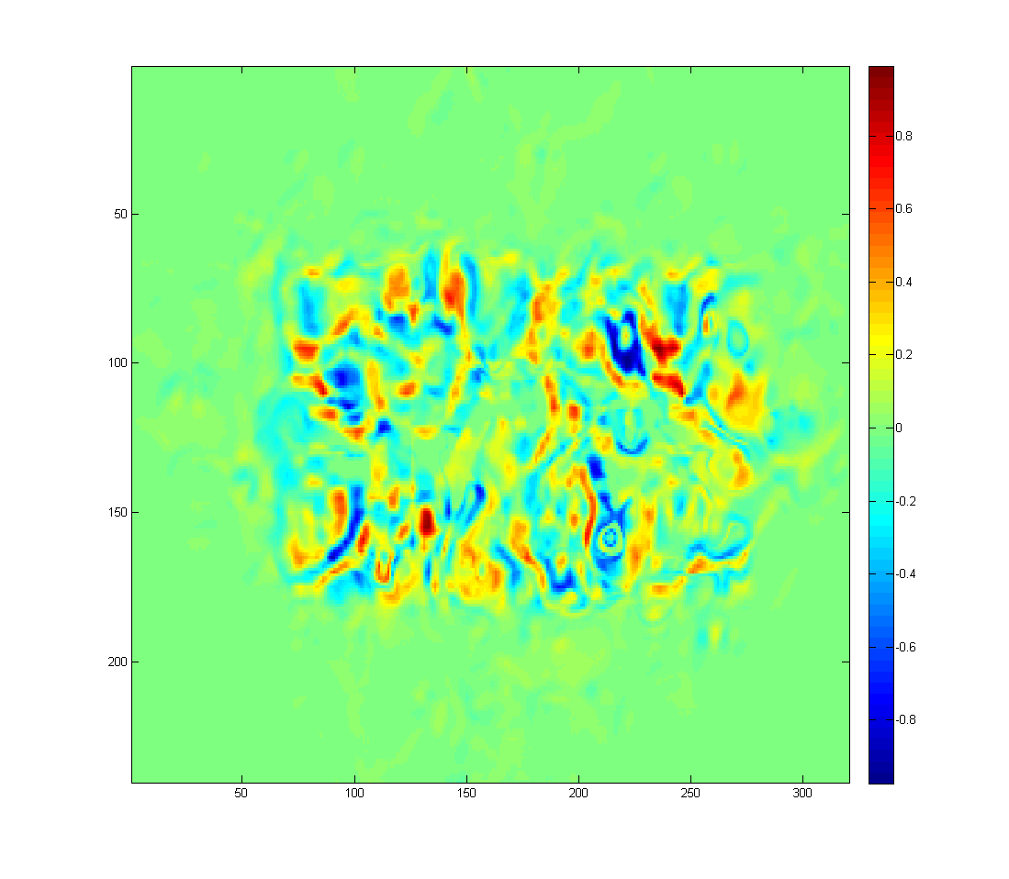

Difference image between Shift0 and warped Shift20, as calculated by a hierarchical LK method, where k=7, each LK operation used a Gaussian filter with window size 30, and sigma 15.

**Problem Set 5, Question 4, Part 1, Images for Shift0 → Shift40 (TestSeq)**

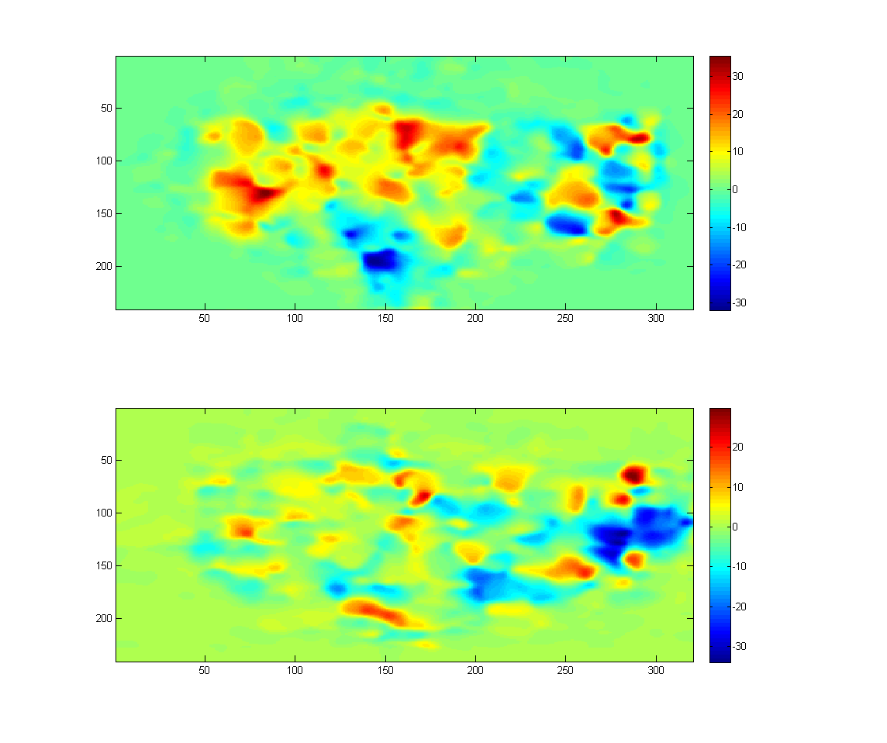

Displacement between Shift0 and Shift40, as calculated by a hierarchical LK method, where k=7, each LK operation used a Gaussian filter with window size 30, and sigma 15.

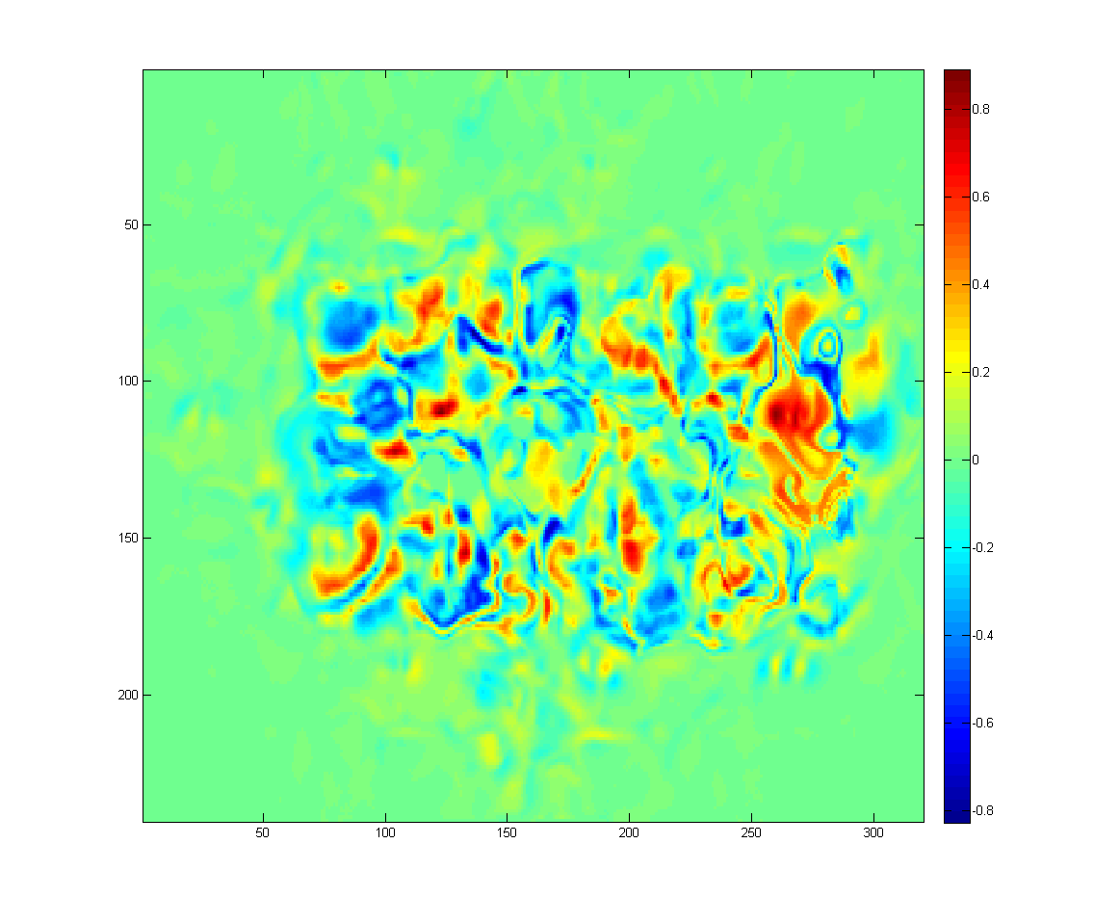

Difference image between Shift0 and warped Shift40, as calculated by a hierarchical LK method, where k=7, each LK operation used a Gaussian filter with window size 30, and sigma 15.

**Problem Set 5, Question 4, Part 1, Images for yos_img_01 → yos_img_02 (DataSeq1)**

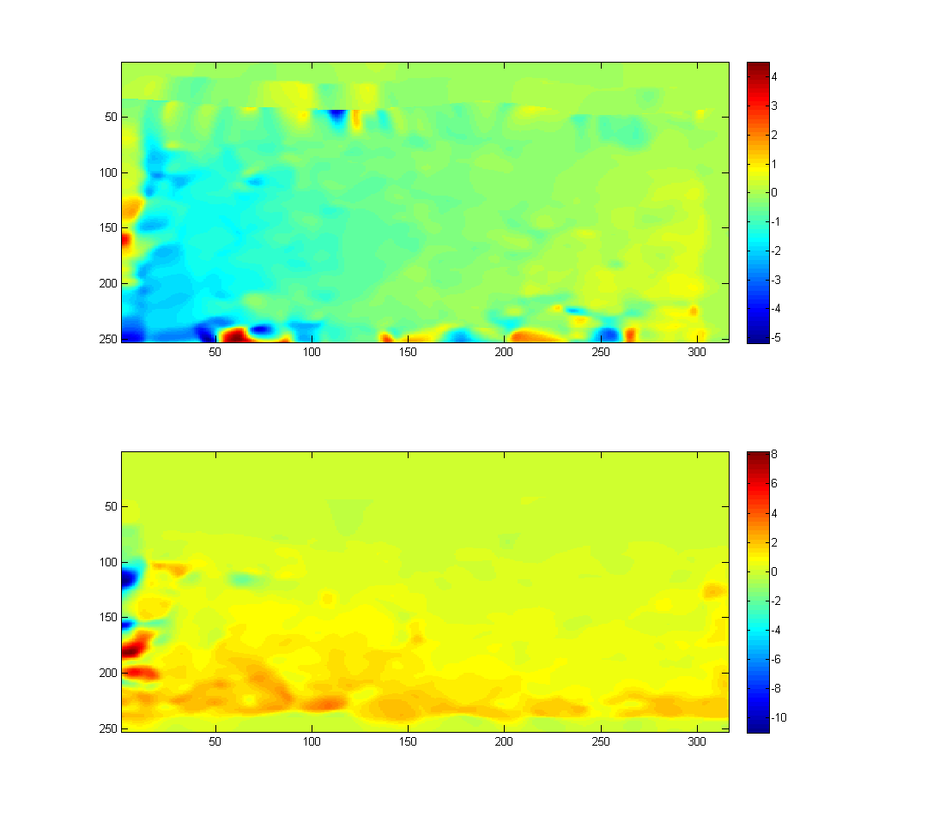

Displacement between yos_img_01 and yos_img_02, as calculated by a hierarchical LK method, where k=7, each LK operation used a Gaussian filter with window size 30, and sigma 15.

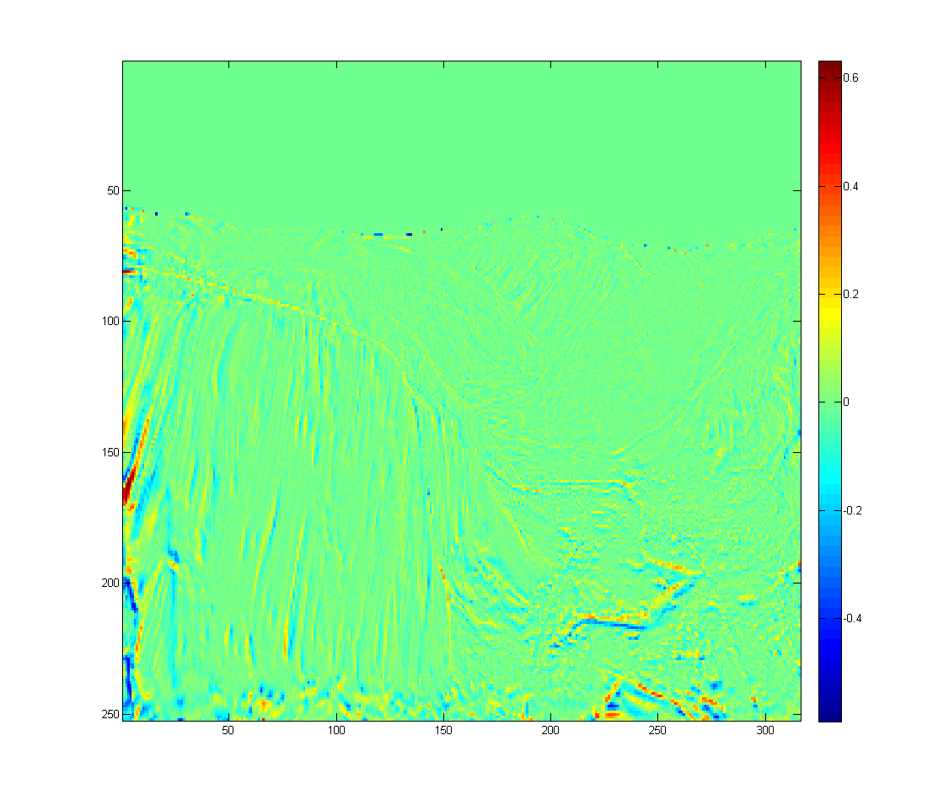

Difference image between yos_img_01 and warped yos_img_02, as calculated by a hierarchical LK method, where k=7, each LK operation used a Gaussian filter with window size 30, and sigma 15.

**Problem Set 5, Question 4, Part 1, Images for yos_img_02 → yos_img_03 (DataSeq1)**

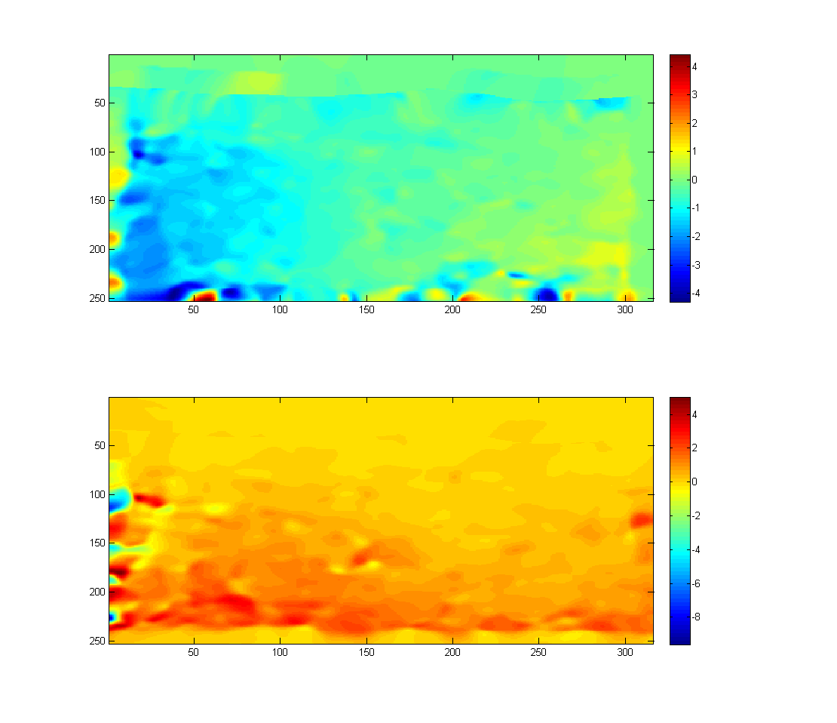

Displacement between yos_img_02 and yos_img_03, as calculated by a hierarchical LK method, where k=7, each LK operation used a Gaussian filter with window size 30, and sigma 15.

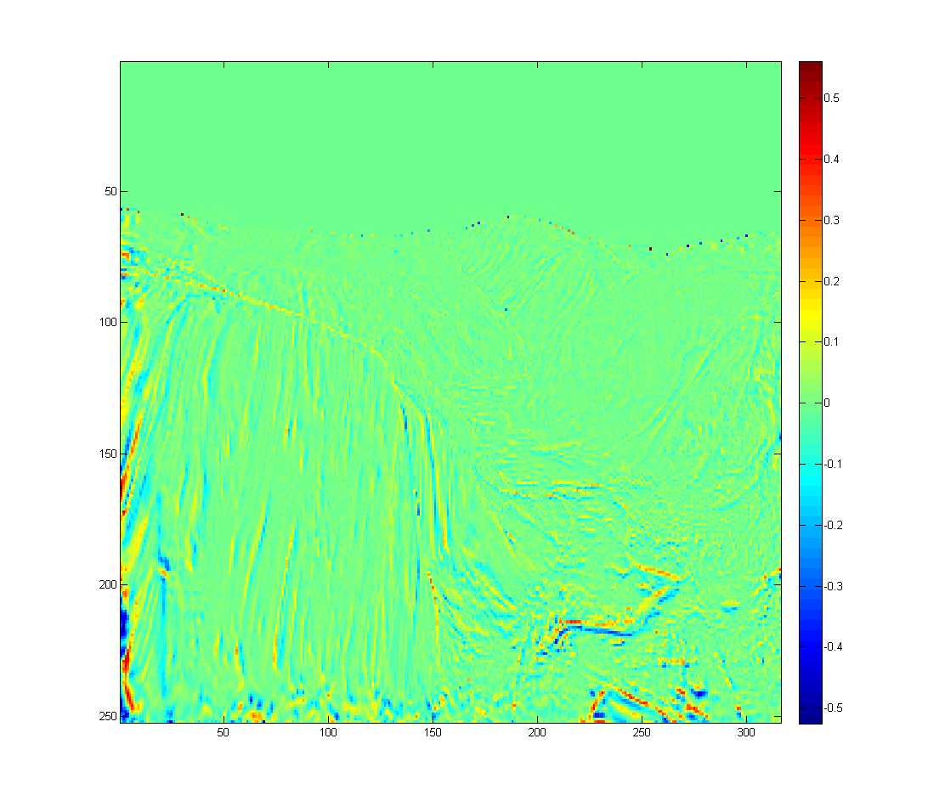

Difference image between yos_img_02 and warped yos_img_03, as calculated by a hierarchical LK method, where k=7, each LK operation used a Gaussian filter with window size 30, and sigma 15.

**Problem Set 5, Question 4, Part 1, Images for 0 → 1 (DataSeq2)**

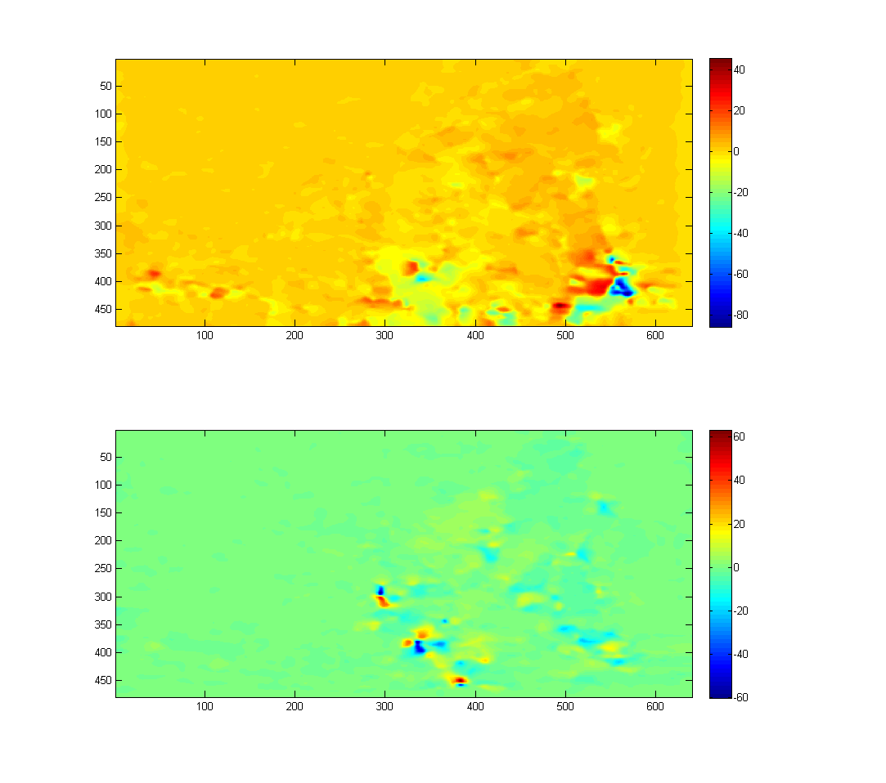

Displacement between 0 and 1, as calculated by a hierarchical LK method, where k=7, each LK operation used a Gaussian filter with window size 30, and sigma 15.

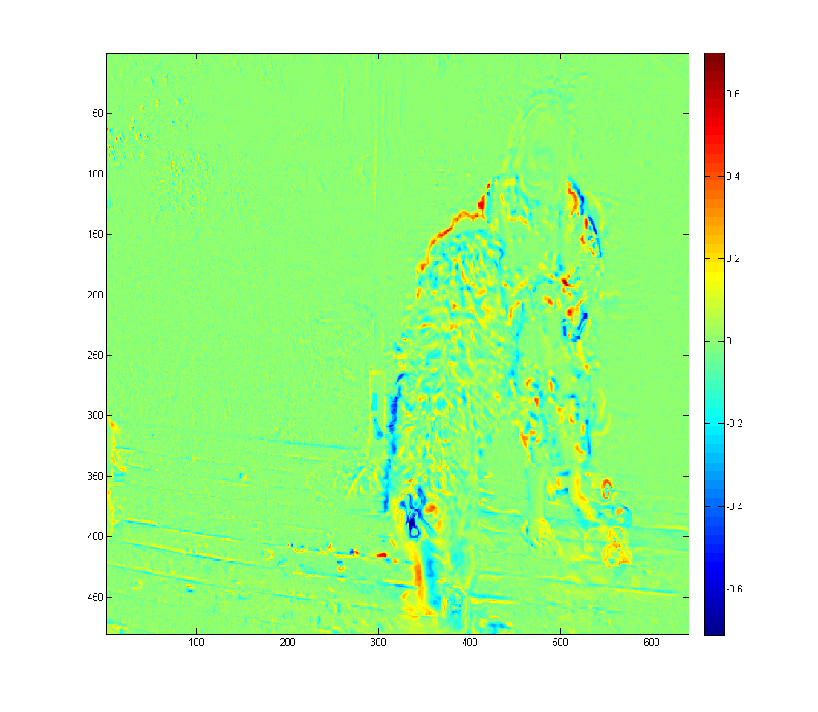

Difference image between 0 and warped 1, as calculated by a hierarchical LK method, where k=7, each LK operation used a Gaussian filter with window size 30, and sigma 15.

**Problem Set 5, Question 4, Part 1, Images for 1 → 2 (DataSeq2)**

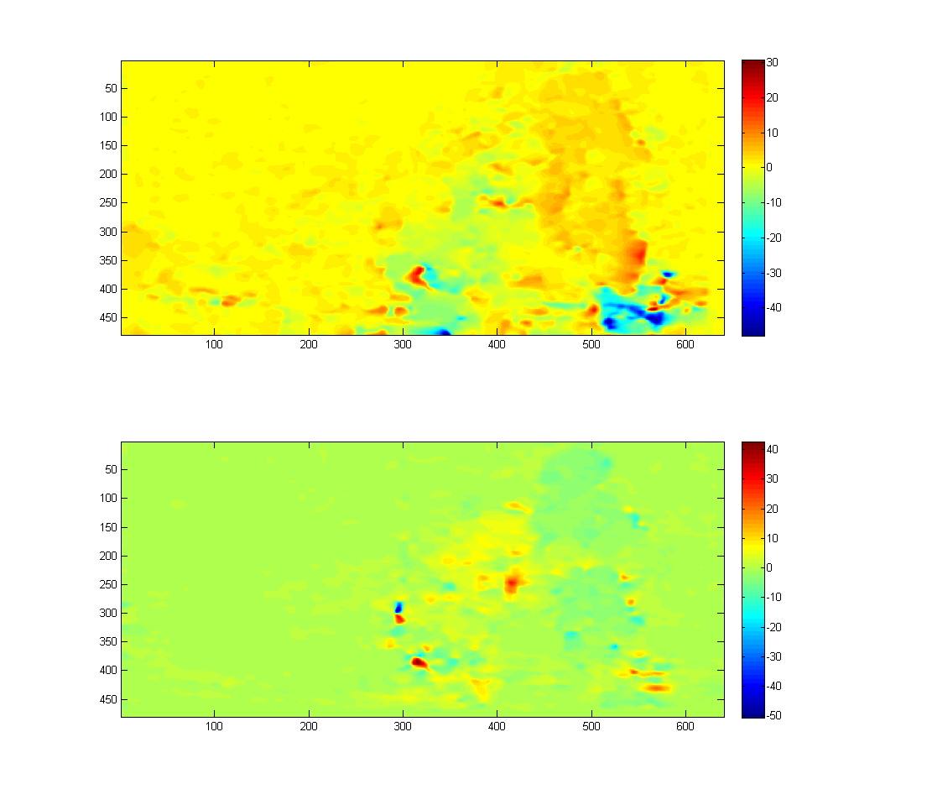

Displacement between 1 and 2, as calculated by a hierarchical LK method, where k=7, each LK operation used a Gaussian filter with window size 30, and sigma 15.

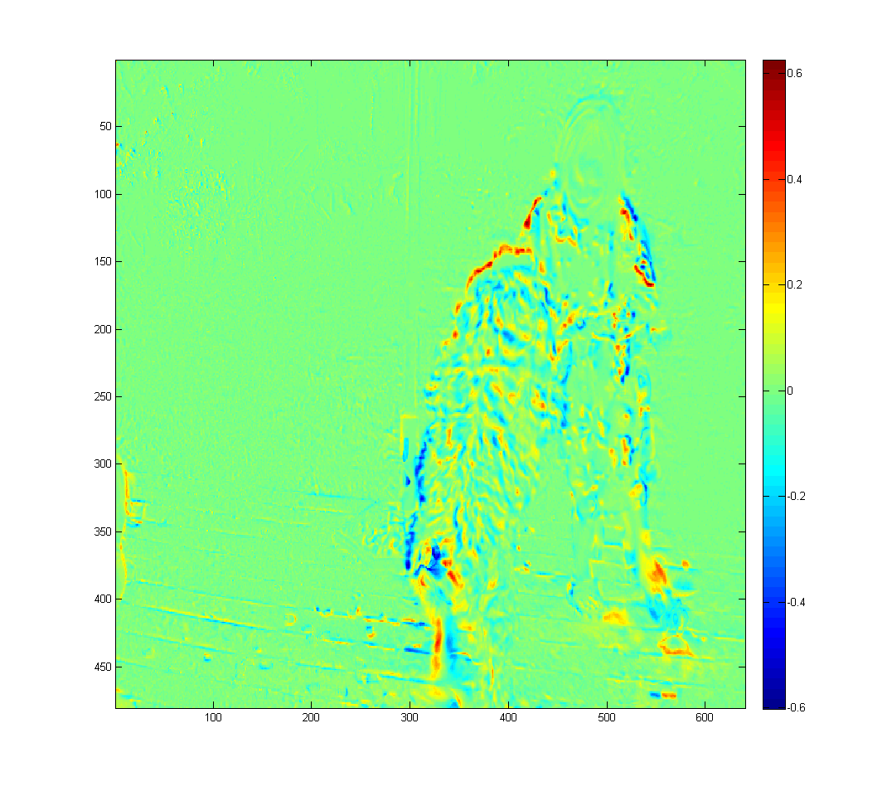

Difference image between 1 and warped 2, as calculated by a hierarchical LK method, where k=7, each LK operation used a Gaussian filter with window size 30, and sigma 15.